Once you have renewed your license (Archiving an IPDP)

- Enter the KIOSK, sign-in and use the apps drop-down to go to the IPDP link.

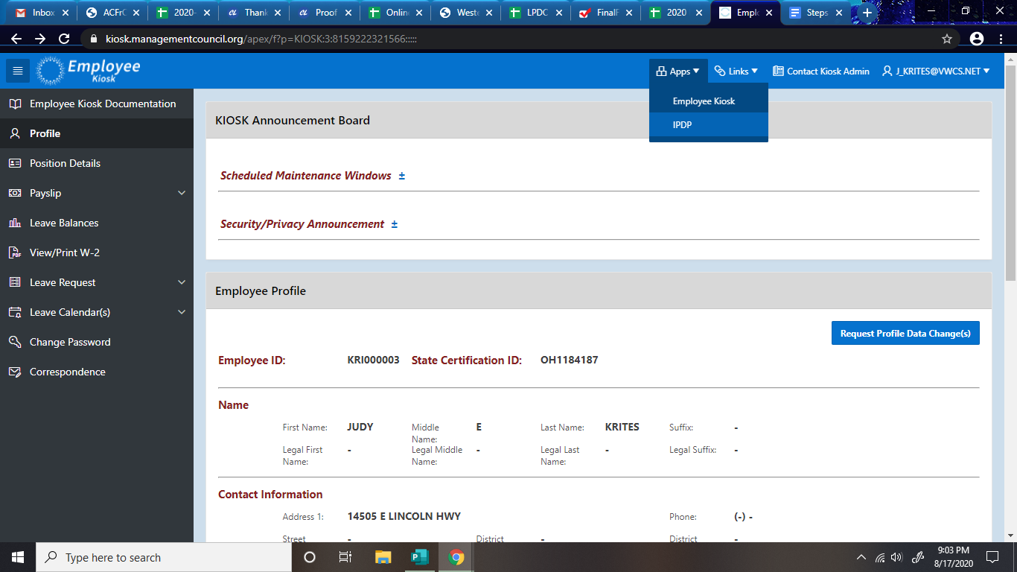

- In the Individual Navigate at the left, choose view plan.

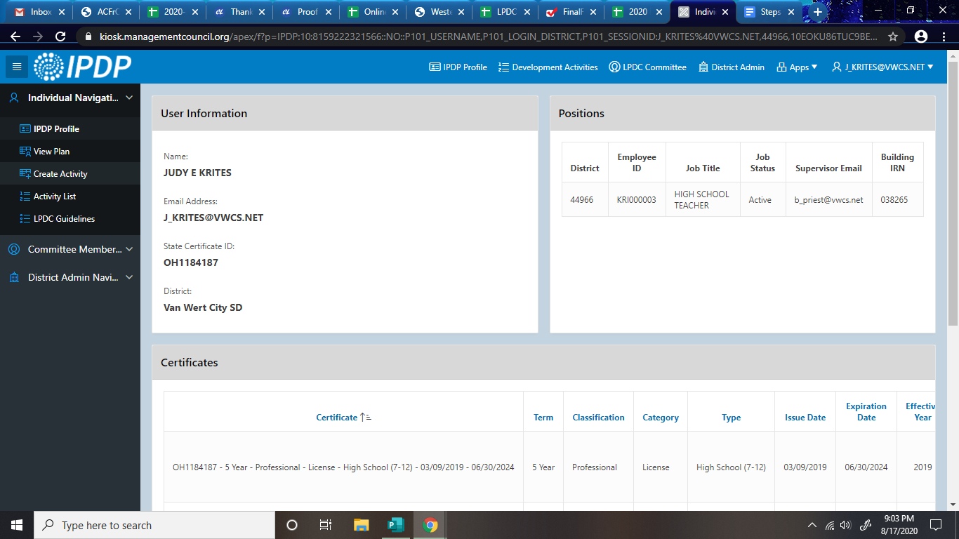

3. Scroll to the options above your current goals and click Archive Plan. You will now be able to follow the steps to create a new IPDP for your next license cycle.
